Rethinking Enforcement:

A Call for NYC DOT to Re-Examine the Impact of Traffic Stops

**Context**

* Racial discrimination in traffic enforcement across the US has been well-documented in academia[1] and the national press[2] as an ongoing problem with severe consequences.
  + In the four states with the best data (CT, IL, NC, RI), Black drivers are both more likely to be pulled over, and more likely to be searched, even though drugs, guns or other contraband were more likely to be found if the driver was white. [3]
  + Unpaid fines can result in license suspensions, which can bind low-income New Yorkers in a choice between facing criminal charges for driving without a license or losing access to jobs or childcare. [4]
  + Criminal summonses for such minor infractions as biking on a sidewalk can lead to a lifetime of the consequences of having a “criminal” record.
* Existing enforcement and regulatory systems objectively produce racially disparate outcomes, in both local and national studies.
  + NYC driver’s license suspension rates are two-and-a-half times higher in ZIP codes with the lowest concentration of white people compared to those with the highest proportion of white residents. [5]

**Evidence of Bias in Enforcement of Cyclists and Pedestrians**

An analysis of available, self-reported NYPD data on summonses issued to pedestrians and cyclists, for which race is available as a field, strongly supports the conclusion that there is bias in traffic stops as practiced (whether driven by police or in response to elected or constituent complaints) as well as intentional targeting of NYCHA residents for purposes not related to traffic safety.

* 32% of roughly 1,500 jaywalking tickets issued over a three-year period were on a block or corner of a NYCHA property despite NYCHA blocks making up only ~3% of all blocks in NYC.[6]
* 97.5% of the 80 people receiving jaywalking summonses were logged as Black or Hispanic in the first three months of 2020.[7]
* Between 2007 and 2015, just four precincts, located on the Upper East Side, Upper West Side, Midtown North, and Midtown East, issued 92% (32,609 of 35,337) of all criminal court summonses for commercial cycling infractions despite only having 13% (2,083 of 16,229) of NYC’s restaurants. In these precincts, non-Hispanic White residents comprise 75% of the population, while delivery cyclists are overwhelmingly immigrants of color.
* The top-ten Community Districts receiving tickets for non-commercial cycling (total of 196,228 between 2007 and 2015) have a population that is on average 83% non-white[8], despite cycling activity being heavily concentrated in whiter neighborhoods in and close to Manhattan, and despite white residents being overrepresented in the cycling population (40%) compared to the city at large (33%).[9]
* Over 80% of the 400 criminal cycling summonses issued in 2019 were given to Black or Hispanic New Yorkers, despite these populations making up only 49% of the cycling population[10].

Proportion of Bicycle Summonses by Race, 2016-2019.

(Source: NYC DOT/Open Data)[11]

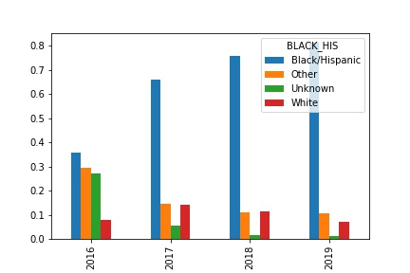

**Conclusions**

In New York City, for the kinds of traffic stops where racial data is available (jaywalking and cycling), we see clear evidence of racial bias.

Although the sample size for jaywalking and recent criminal citations is low, it is relevant that analysis of all the available data points in the same direction, especially when viewed in light of a national context of overwhelming evidence of bias in policing.

In addition to contributing to serious negative consequences for communities and individuals subject to over-policing, the mere *perception* of this racial bias in police traffic enforcement also negatively impacts transportation outcomes and is likely to make it harder for NYC DOT to forge strong relationships with communities of color necessary to effectuate its policy goals.

In tension with the above are findings at the national level that increased police traffic enforcement does, in fact, lead to fewer crashes with injuries.[12] Data to perform a local analysis has only recently become available.

A safer city for all, however, requires grappling with these difficult issues and giving full consideration of the potential for traffic enforcement to cause the tragic loss of life as well as to prevent it. NYC DOT can and should rise to the challenge of carefully assessing its designs, messaging, policies, practices, budget, and partnerships and developing creative solutions that increase public safety and wellness--for all its people.

Appendix 1: [Tables](http://www.intersectionalriding.com/wp-content/uploads/2016/12/top-precincts-3.pdf) **from “Biking While Immigrant,” Biking Public Project**

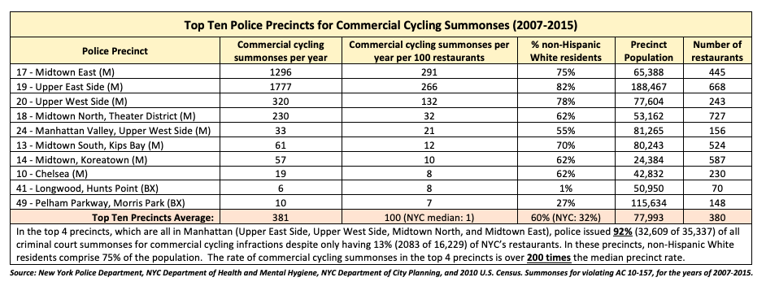

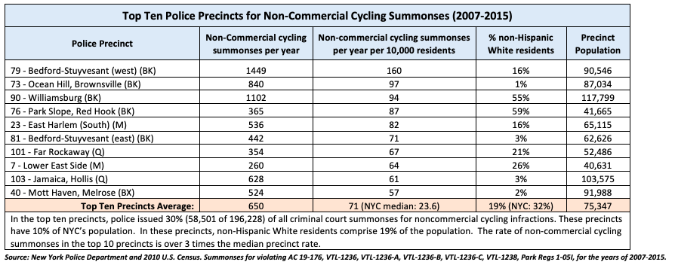

1. Baumgartner, Frank et al. [Racial Disparities in Traffic Stop Outcomes. Duke Law, 2017](https://scholarship.law.duke.edu/cgi/viewcontent.cgi?referer=https://scholar.google.com/&httpsredir=1&article=1065&context=dflsc)
2. “["The Disproportionate Risks of Driving While Black"](https://www.nytimes.com/2015/10/25/us/racial-disparity-traffic-stops-driving-black.html) *New York Times,* Oct. 25, 2015
3. ibid.
4. [Driving While Black and Latinx: Stops, Fines, Fees, and Unjust Debts (NY Law School, 2020)](http://www.nyls.edu/racial-justice-project/wp-content/uploads/sites/173/2020/02/RJP-drivers-license-suspension-final.pdf)
5. ibid.
6. NYC DOT analysis of available summonses from 2016, 2017, and 2019 (NYPD/OpenData) [WHAT ABOUT 2018? DATA NOT AVAILABLE?]
7. NYC DOT analysis of Open Data
8. [“Biking While Working Immigrant](http://www.intersectionalriding.com/2016/12/14/biking-while-working-immigrant/)” Biking Public Project, based on Open Data available 2007-2015
9. “[Safer Cycling](https://www1.nyc.gov/html/dot/downloads/pdf/bike-safety-study-fullreport2017.pdf),” NYC DOT, 2017
10. ibid
11. Data source: [Open Data](https://data.cityofnewyork.us/Public-Safety/NYPD-Criminal-Court-Summons-Historic-/sv2w-rv3k/data) downloaded data with filter SUMMONS_CATEGORY_TYPE == 'BIKE'
12. Greer, Stuart. [“Does police traffic enforcement result in safer roads? A critically appraised topic.”](https://www.cebma.org/wp-content/uploads/CAT-Stuart-Greer.pdf) NYU Wagner